**TO DO FOR WEBSITE (PARA TECH EXPO)**

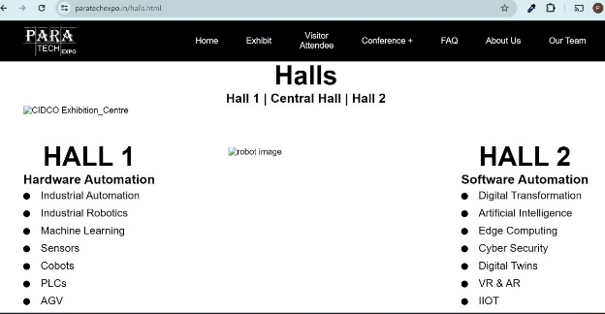

All images are not working properly

1. Benefits of PARA TECH Expo Attendees

**Correct: Benefits of attending PARA TECH Expo**

2. Attendees Registration form

**Correction: Visitor/Attendees Registration form**

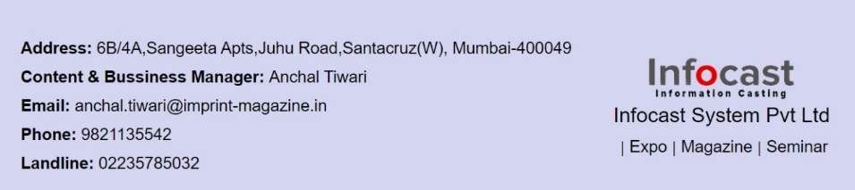

Same way Details has to be put in para website

Email: [anchal.tiwari@paratechexpo.in](mailto:anchal.tiwari@paratechexpo.in)

Booking Form

correction: Exhibitor Booking From





